Te Kopuru School
Norton Street.
P.O Box 20
Te Kopuru
Ph/Fax (09) 439 1802
Email: office@tekopuru.school.nz

PINK Mufti Day
To promote Bully-Free
Tomorrow
Wednesday 18 May

17 May 2022

Whakatauki

Dear Parents and Caregivers,
Tenei te mihi atu ki nga matua katoa.

This week is BULLYING-FREE NZ. Bullying is a serious issue that all schools and many other places face. Every member of our school community has a role to play in preventing and stopping bullying.

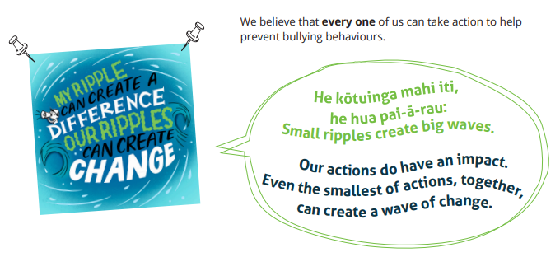
What is bullying?
Bullying is when someone keeps picking on you. Bullying can be physical (like hitting or kicking); verbal (like putting you down or spreading rumours); emotional (excluding you from groups, taking your stuff or forcing you to do things you don’t want to); or online (posting nasty things about you, sending embarrassing pictures or videos of you to others).
Bullying can happen face-to-face, online or on mobile phones. It can happen in front of everyone or when no one else is watching.
Sometimes you might fight or argue with someone. If this happens only once, it’s not bullying even though you might feel upset.
As a school we continue to focus on a ‘culture of care’. This includes a ‘safe-telling’ culture that encourages all students to report bullying incidents. This may be to a teacher or friend, or it may be to parents and caregivers.
Please keep us informed on any incidents so that we may work together to tackle bullying.

Strategies we encourage our students who are being bullied are:
● Get help - don’t keep a secret
● Talk to someone you can trust - a teacher, parent, friend
● Ignore it - walk away
● Stay cool and calm
● Keep safe - fighting back can make it worse
● It’s OK to feel scared - telling is the right thing to do
We want all our students to be responsible and to show they care. Strategies we are telling our children to use:
● Walk away and tell an adult
● Don’t laugh and join in
● Be kind to the kid being bullied - show them you care
● Take the student away from the bullying
● Tell them no one deserves to be bullied
● Ask the kid being bullied to join in with you and your friends
“Oat the Goat” is a new resource for us to share and talk about with our children: - an exciting animated story that is designed to help young students learn about the power of kindness and to make right decisions. I encourage parents to use this resource at www.oatthegoat.co.nz

Create and Relate Mentors:
This week we welcomed our two new create and relate mentors to our school. This is a new initiative trialing for term 2 at this stage, where mentors interact with our students in the social arena. Whaea Paula and Matua Rod will be setting in place activities and programmes at break times and lunchtimes so that no child is left alone; and students are involved in purposeful, respectful and fun games that promote our school values of pono, tika and aroha.
This is an exciting initiative that will further support the hauroa and well-being of our students. Welcome on board Rod and Paula!

Rugby Under 9’s Lunchtime Training:

There will be under 9’s rugby training at school, every Thursday, during Lunchtime. 12.45pm to 1.15pm. Any queries, please contact Josh Kena or Michael Rope.

Steps Programme:

A number of students throughout the school have been selected to work on the Steps Programme. This enhances their literacy skills of reading, writing and spelling.

Whaea Dawn oversees the programme and this year will assisted by Sherryl Rope, our RTLB (Resource Teacher for Learning and Behaviour).

If you have any queries or would like to know more about Steps, please contact the office.

Covid update:
Two families and one staff member have tested positive with Covid.
There are also lots of children with sniffles and coughs. Please keep your child at home if they are sick, and contact the school to report an absence.

Please take care and keep safe.

Lee Anderson

